Course Name: Web Programming.

*Homes & Lands.*

*Professor. Abdel razzaq al natsheh*



**Team Members:**

Malek Saed . 11613882

Eyad Shamlouli 11715933

The goal of our website is to help people choose the right property (homes or lands).

We have a special service called value my home which helps the user to value his property’s correct price.

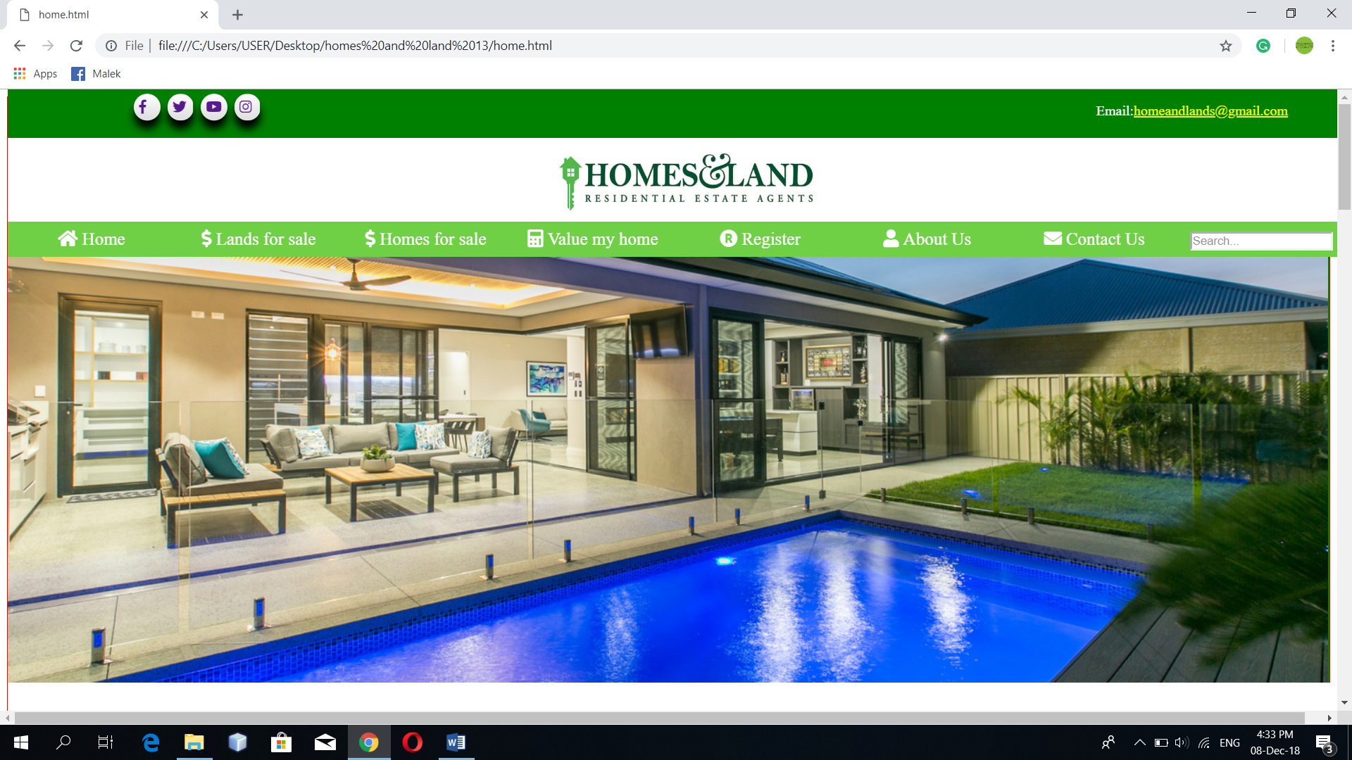

We have used two public libraries the first one is font awesome which creates small symbols.

The second one is animate which we used to create a beautiful animation in our website.

We have inserted a header in our website, which contains social media buttons float:left; , and an email with float:right property with a link.

For the logo we used a website that generates a logo and we used that logo and styled it with margin : auto;

For the main menu we used unordered list with list style :none; and background-color : green; also when hovering it changes the color in the main menu we used the symbol library (font awesome).

We also inserted a search cell that takes a string then it filters it with the help of java script.

All what we have just said is in the header and styled with position : fixed; .

For the content we used a slider function to navigate through images by using a for loop and we used set timeout function to set the time between each image we also used display : none; we also referenced all images in a class with the help of java script .

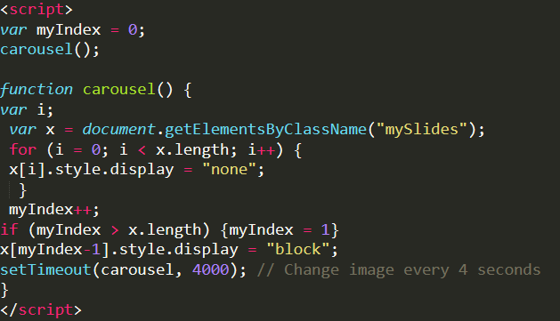

We used the element <p> and <h3> to talk more about the website, we styled it with color:green; and text-align : center; also font : size;

Then we used divs inside those divs we inserted images with a styling of position : relative ; and a button with position : absolute; to put the button inside the image also used margin to align images in order.

As for the footer we used background :green also we used background : grey; we wrote our branches location and contact info. And styled it with margin and padding also it changes color when hovering.

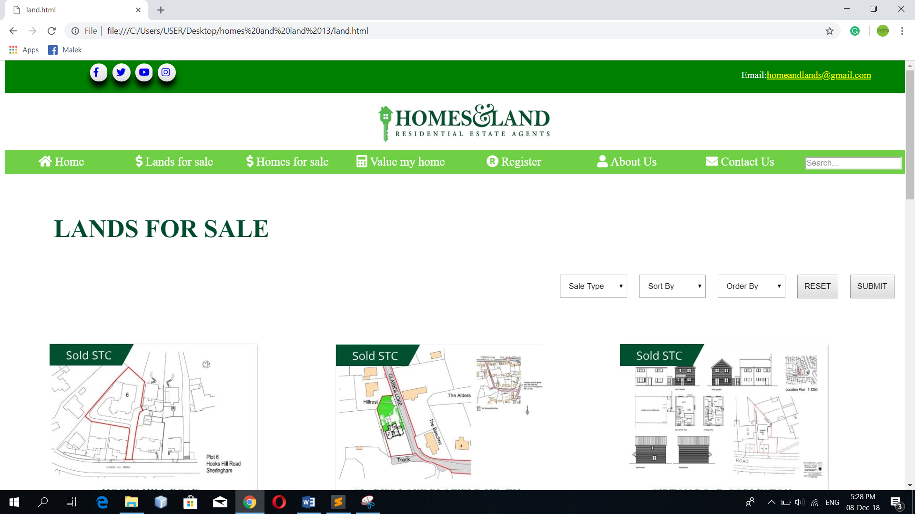

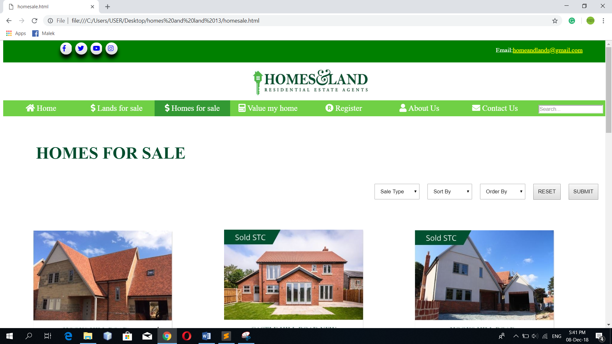

in this page we used an <h1> element and styled it with color:green; and margin left and top.

Then we used a selector with option element and a button and positioned it with float:right;.

Then we used divs inside each div is an image and the div is lined using margin the image is also styled with position relative and a button with position : absolute; the goal is to place the button inside the image.

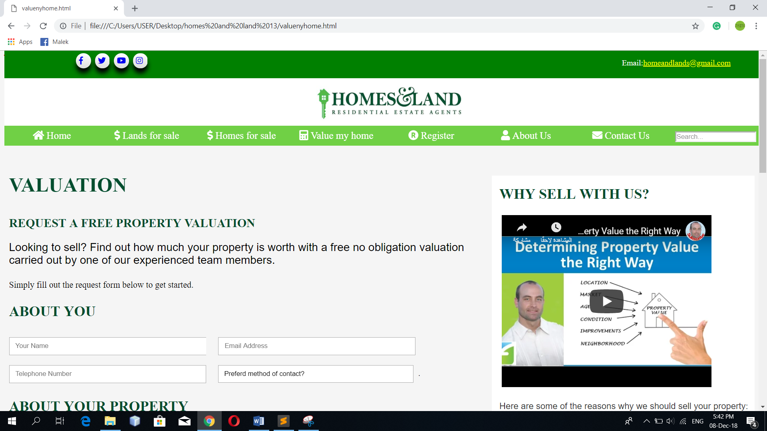

In this page we used an <h1> <p> element and styled it with margin and color and also font-family.

Then we used a form to collect data from user inside the form is the following elements input, radio, select and we positioned them with margin and padding.

Then we used a div inside that div we used the <iframe> element so we can insert a youtube video that explains the steps of valuation.

Also we used unordered list explains why you should hire us.

Also we used divs each div contains an image that shows an example of a sold property.

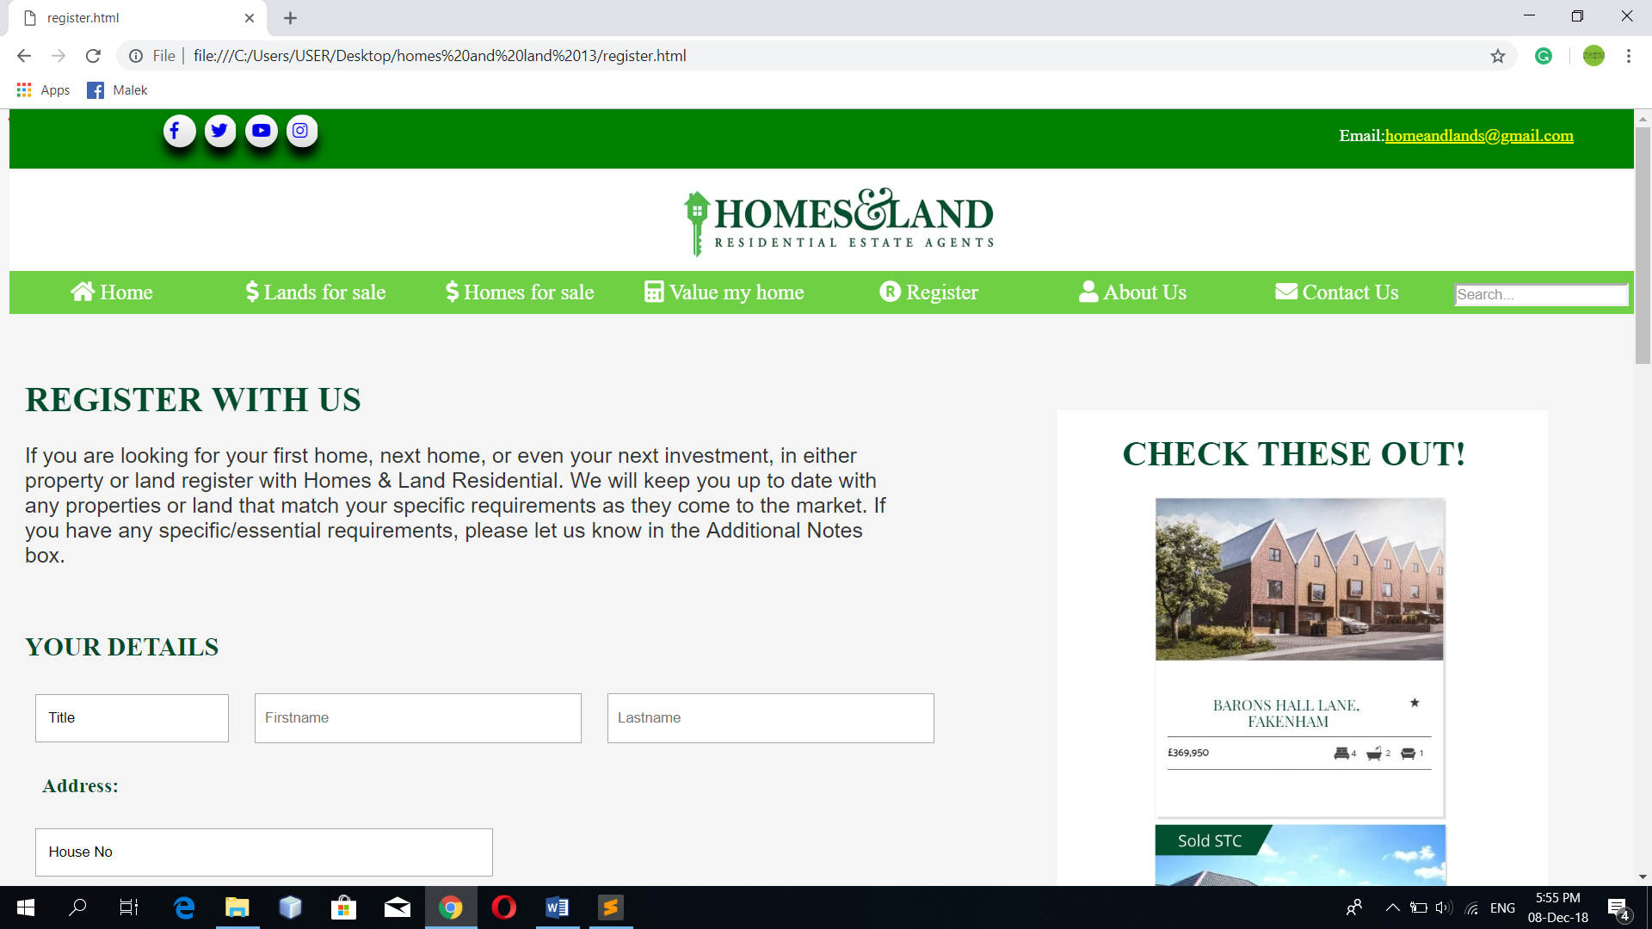

In this page we used an <h1> element and styled it with color:green; and margin top and left as for <p> tag we used a specific width for the paragraph and we used font-family; then we used forms that we aligned with float:left; and margin we also used radio buttons and textarea .

Then we placed a link for the users with an existing account so that they can login

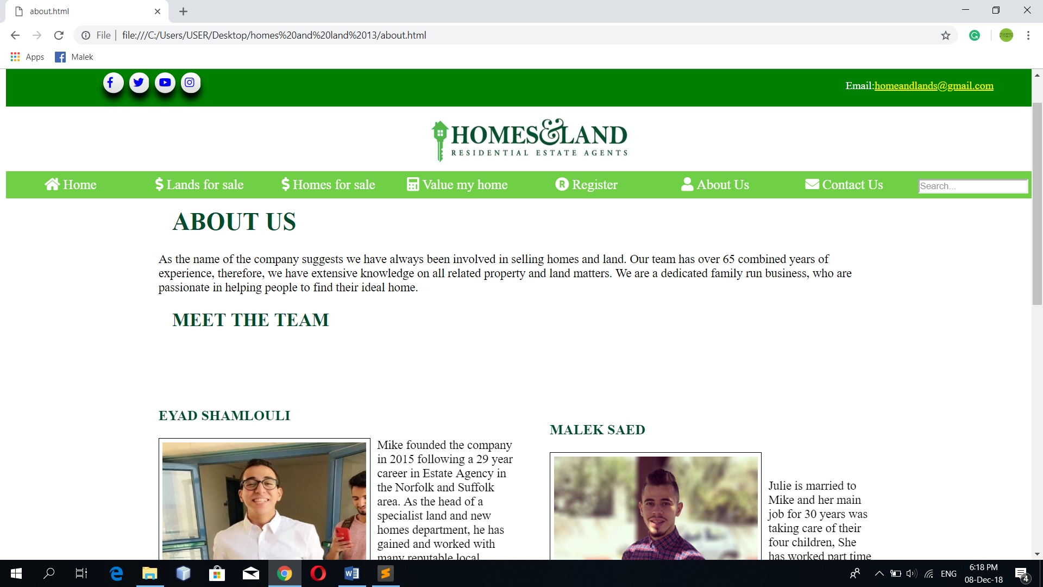

We used two divs inside each <div> is an image with a paragraph we styled the image with float left so that the <p> is placed next to the image also we used border and padding around the image.

Same goes for the right div.

All in which are placed inside the wrapper.

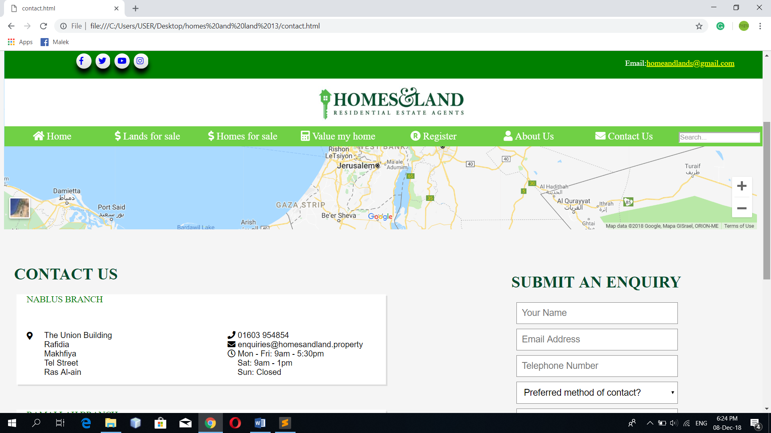

Here we used <iframe> tag to insert a map showing the location of our branch then we used <h1> and styled it with color:green; and margin.

And we used two divs with background color white inside each div is our contact info then we used a form and positioned it with float:left left; inside the form we used <input> <select> <button>